App Flow

Onboarding and KYC
A new user signs up, sees a short feature tour, then verifies identity and the home building; unverified users can look around but reports need verification (with a limited SOS path).
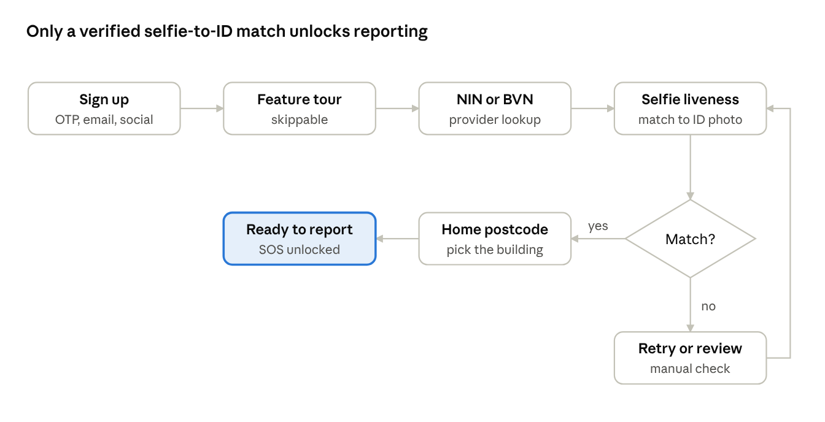
onboarding and KYC flow · 6 steps, 1 decision, 1 retry loop

Emergency report to resolution
A report is routed in seconds, accepted by an officer, tracked live and closed with an outcome; false alarms and transfers branch off the main path.
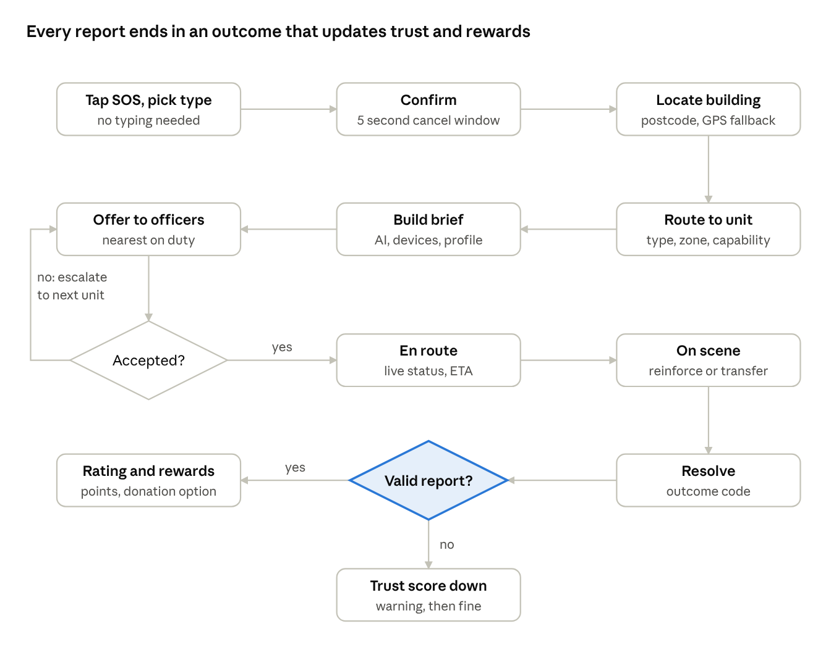
report to resolution flow · 9 steps, 2 decisions, 1 escalation loop

Role flows
Citizen and household owner
- Sign up (phone, email or social), take the tour, verify with NIN or BVN and a selfie, confirm the home postcode.
- Optionally subscribe a property: choose plan, pay installation fee and first subscription on Paystack, book the install visit, see device status after install.
- Report: SOS, type, confirm, track, rate, optionally donate.
- Manage: report history and stats, trust score and fines (with appeal), subscription and receipts, household members.
Agency, station and officer onboarding
- Agency registers with documents; platform admin reviews and approves.
- Agency admin creates stations or locations, sets zones, and names a head for each.
- Heads invite officers by phone or email; officers verify identity and badge, then join a duty roster.
- Heads set incident types handled, routing rules and reinforcement partners.
- Agency links a bank account for rewards and donations (Paystack subaccount).
Officer
- Go on duty; receive an offer with the brief; accept or decline.
- Navigate to the building, update status (en route, on scene), add notes and photos.
- Request reinforcement or transfer from the app; request a drone if the unit has the programme.
- Close with an outcome code; see rating and reward points.
Station head
- Watch the incident queue and officer map; reassign, reinforce or transfer.
- Review logs, ratings and unfounded reports; sign off the monthly report.
Platform admin
- Review KYC exceptions, appeals and fines.
- Manage the device registry and install schedule; open cameras only with a recorded reason.
- Manage subscriptions, plans, price and revenue-share settings, and payouts.
- Monitor system health and agency response metrics.

